Lab Assignment 2

Chaudhary Hamdan

1905387

Date: 21-01-2022

Questions:

1. Min Min Scheduling Algorithm:

Code:

// Author: Chaudhary Hamdan, 1905387

// Generated at: Fri Jan 21 12:47:09 2022

#include<stdio.h>

#include <limits.h>

int main() {

#ifndef ONLINE_JUDGE

freopen("C:\\Users\\KIIT\\input", "r", stdin);

freopen("C:\\Users\\KIIT\\output", "w", stdout);

#endif

int tasks, machines;

scanf("%d%d", &machines, &tasks);

int minMin[machines][tasks];

int table[machines][tasks];

int makespan = 0;

for (int i = 0; i < machines; i++)

for (int j = 0; j < tasks; j++) {

scanf("%d", &minMin[i][j]);

table[i][j] = minMin[i][j];

}

printf("Original Data\n");

for (int i = 0; i < machines; i++) {

for (int j = 0; j < tasks; j++)

printf("%d ", minMin[i][j]);

printf("\n");

}

int resultTask[tasks];

int resultMachine[tasks];

int resultTime[tasks];

int ptr = -1;

while (ptr < tasks - 1) {

int time[tasks], machine[tasks];

for (int j = 0; j < tasks; j++) {

int minimum = INT_MAX;

int pos = -1;

for (int i = 0; i < machines; i++) {

if (minMin[i][j] < minimum) {

minimum = minMin[i][j];

pos = i;

}

}

time[j] = minimum;

machine[j] = pos;

}

int minimum = INT_MAX;

int pos = -1;

for (int j = 0; j < tasks; j++) {

if (time[j] < minimum) {

minimum = time[j];

pos = j;

}

}

resultTask[++ptr] = pos;

resultMachine[ptr] = machine[pos];

resultTime[ptr] = table[machine[pos]][pos];

if (minimum > makespan)

makespan = minimum;

for (int i = 0; i < machines; i++) {

for (int j = 0; j < tasks; j++) {

if (j == resultTask[ptr])

minMin[i][j] = INT_MAX;

else if (i == resultMachine[ptr] && minMin[i][j] != INT_MAX)

minMin[i][j] += minimum;

else

continue;

}

}

}

printf("\nScheduled Task are :\n");

for (int i = 0; i < tasks; i++) {

printf("Task %d Runs on Machine %d with Time %d units\n", resultTask[i] + 1, resultMachine[i] + 1, resultTime[i]);

}

printf("\nMakespan : %d units\n", makespan);

return 0;

}

Output:

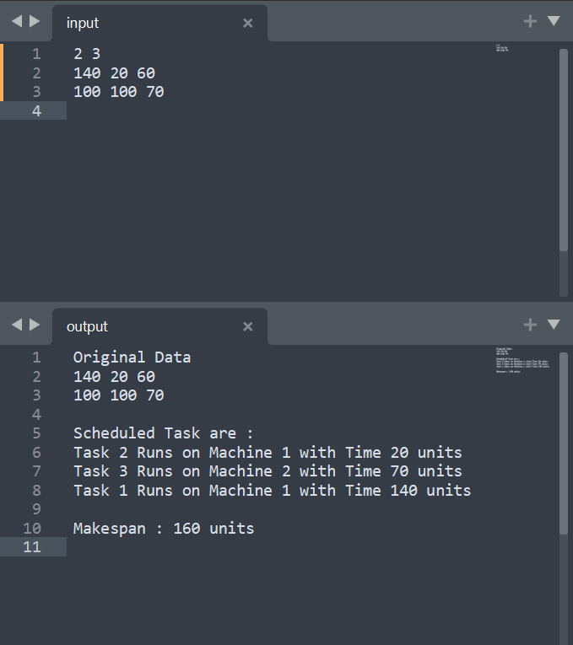

1. Max Min Scheduling Algorithm

Code:

// Author: Chaudhary Hamdan, 1905387

// Generated at: Fri Jan 21 12:47:25 2022

#include<stdio.h>

#include <limits.h>

int main() {

#ifndef ONLINE_JUDGE

freopen("C:\\Users\\KIIT\\input", "r", stdin);

freopen("C:\\Users\\KIIT\\output", "w", stdout);

#endif

int tasks, machines;

scanf("%d%d", &machines, &tasks);

int maxMin[machines][tasks];

int table[machines][tasks];

int makespan = 0;

for (int i = 0; i < machines; i++)

for (int j = 0; j < tasks; j++) {

scanf("%d", &maxMin[i][j]);

table[i][j] = maxMin[i][j];

}

printf("Original Data\n");

for (int i = 0; i < machines; i++) {

for (int j = 0; j < tasks; j++)

printf("%d ", maxMin[i][j]);

printf("\n");

}

int resultTask[tasks];

int resultMachine[tasks];

int resultTime[tasks];

int ptr = -1;

while (ptr < tasks - 1) {

int time[tasks], machine[tasks];

for (int j = 0; j < tasks; j++) {

int minimum = INT_MAX;

int pos = -1;

for (int i = 0; i < machines; i++) {

if (maxMin[i][j] < minimum) {

minimum = maxMin[i][j];

pos = i;

}

}

time[j] = minimum;

machine[j] = pos;

}

int maximum = INT_MIN;

int pos = -1;

for (int j = 0; j < tasks; j++) {

if (time[j] > maximum && time[j] != INT_MAX) {

maximum = time[j];

pos = j;

}

}

resultTask[++ptr] = pos;

resultMachine[ptr] = machine[pos];

resultTime[ptr] = table[machine[pos]][pos];

if (maximum > makespan)

makespan = maximum;

for (int i = 0; i < machines; i++) {

for (int j = 0; j < tasks; j++) {

if (j == resultTask[ptr])

maxMin[i][j] = INT_MAX;

else if (i == resultMachine[ptr] && maxMin[i][j] != INT_MAX)

maxMin[i][j] += maximum;

else

continue;

}

}

}

printf("\nScheduled Task are :\n");

for (int i = 0; i < tasks; i++) {

printf("Task %d Runs on Machine %d with Time %d units\n", resultTask[i] + 1, resultMachine[i] + 1, resultTime[i]);

}

printf("\nMakespan : %d units\n", makespan);

return 0;

}

Output:

